Assignment-1

Name:- Mayukh Barman Ray

Roll No.:-04 , CSE , 2nd Year

P1>

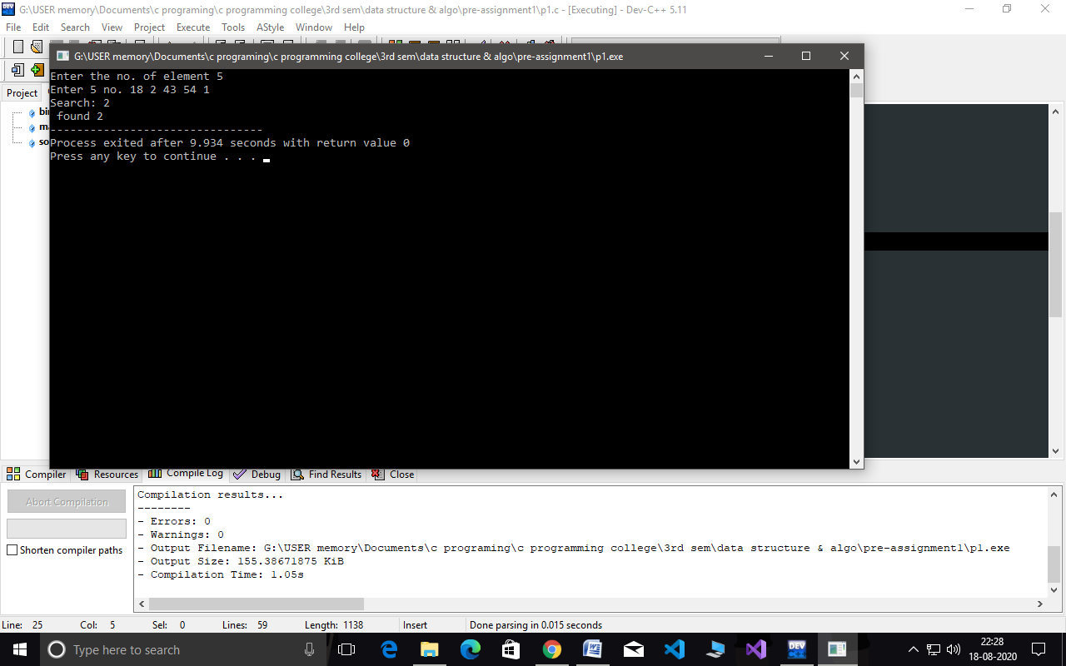

P2>

